ON-THE-JOB-TRAINING
COLLEGE OF ARTS, SCIENCE, AND TECHNOLOGY

Student Name: Micah Mel R. Madriaga
Student ID: MA22-IT-06293
Course & Year and Section: Bachelor of Science in Information Technology, 4-G
Internship Period: Jan 29, 2026 – April 21, 2026
Host Company: Civil Aviation Authority of the Philippines
OJT coordinator: Marites D. Escultor, MSIT

Table of Contents

Title Page
Table of Contents
Acknowledgment
Student Trainee Prayer
Personal Philosophy
Career Plan

Chapter I: Introduction

A. Importance of Internship
B. Objectives of Internship
C. Time and Place

Chapter II: Company Profile

A. Nature of the Agency
B. Mission/Vision/Goal Statement
C. History/Background of the Agency/Office
D. Organizational Structure

Chapter III: Work Experiences

A. Weekly Accomplishment Report
B. Daily Time Record
C. Internship Progress Report
D. Internship Analysis Report

Chapter IV: Assessment of the Practicum Program
A. Student Internship Evaluation Form

Appendices

Appendix A: Evaluation Form
Appendix B: Photocopy Registration Form
Appendix C: Photocopy Validated ID
Appendix D: Parent's Consent
Appendix E: Medical Certificate
Appendix F: Certificate of Good Moral Character & Application Letter
Appendix G: Application Letter
Appendix H: Endorsement Letter
Appendix I: Memorandum of Agreement
Appendix J: Daily Time Record (Time Card)
Appendix K: Certificate of Completion
Appendix L: Certificate of Clearance
Appendix M: Pictures during Pre-service Seminar
Appendix N: Pictures during Office Works
Appendix O: Code of Ethics for CAST Student Internship
Appendix P: Curriculum Vitae
Appendix Q: On-the-Job Training Portfolio Evaluation Form

Acknowledgment

I would like to express my heartfelt thanks to everyone who supported me throughout my On-the-Job Training journey.

To our OJT coordinator, Ms. Marites D. Escultor, thank you for your guidance, encouragement and constant support.
To CAAP Air Traffic Service, especially to Mr. Delmer M. Palara, Mrs. Aylene Z. Villanueva, Mr. Ervin J. Asuncion, Mr. John Paul L. Gomez, Thank you for sharing your Knowledge, Mentorship, Valuable Life Lessons and Fun Moments.

To my family, thank you for your love, support, and motivation throughout this experience.

And most of all, to Almighty God, thank You for the strength, wisdom, and guidance in completing this training.

I will carry the lessons, experiences, and insights gained from this journey into my future career.

Student Trainee Prayer

Dear Heavenly Father,

As I begin my journey as a student trainee, Lord I humbly ask for Your guidance and wisdom. Lord Grant me knowledge and skills to perform my task well and to learn from every experience.
Lord, give me strength, and wisdom to face challenges
Lord, help me to Build a good relationship with my Supervisor and Staffs
Lord, please help me in this training to be my stepping stone toward to my future career
Lord please Forgive me for my mistakes and weaknesses
Thank You for the blessing of this opportunity to serve as a student trainee. Thank You for guiding me to this journey, Thank You for the lessons, experiences and for the skills that I have acquired during the process.

Amen.

Personal Philosophy

My personal philosophy during my On-the-Job Training is to learn with dedication, work with integrity, and perform every task with responsibility. I believe that every experience, whether easy or challenging, is an opportunity to grow and improve myself for my future career.

I believe that OJT is not only about completing tasks but also about building character, improving skills, and preparing for future responsibilities. Through dedication and a positive attitude, I aim to become a competent and responsible professional.

Life is not a race, it's a journey. And I want to walk it with purpose, passion, and integrity.
Career Plan

Immediate Goals

- Secure a full time job in Civil Aviation Authority of the Philippines after graduation
- Target roles such as Fire Officer and Air Traffic Controller

Skill Development Focus
- I will focus on developing technical and professional skills needed in air traffic service operations.
- Study and Master Air Traffic Service Operations
- Focusing on improving communication skills in dealing with Air Traffic Service Personnel and Pilots
- I also aim to strengthen my discipline, attention to detail and ability to work under pressure.

Long term vision

- My long-term vision is to become successful and stable in Air Traffic Service or related fields within the Civil Aviation Authority of the Philippines.

- I aim to become a skilled and competent aviation professional who contributes to safe and efficient Air Traffic operations in the country.

Personal Commitment

- I am committed to performing my duties with dedication, honesty, and professionalism
- I will respect workplace rules and to maintain good relationships with CAAP employees
- I will stay focused and dedicated, knowing that this training is an important step in preparing me for my future career in the Civil Aviation Authority of the Philippines

E-Portfolio Contents
Navigate through the comprehensive documentation of your internship experience

Chapter 1: Introduction
(Overview of internship importance, objectives, and setting)

Chapter 2: Company Profile
(Details about the host company, its mission, and structure)

Chapter 3: Work experiences
(Weekly Reports, Time Records, and Project Documentation)

Chapter 4: Assessment
(Evaluation forms and internship performance assessment)

Appendices
(Additional documentation, Certificates and attachments)

CHAPTER I

Introduction
Foundation and Framework of the Internship Program

A. Importance of Internship

Molding Future IT Professionals

Internship is a crucial aspect of the life of an IT student. It is a transition from learning in school to the real world. This experience affects not just our technical abilities and it includes our character. We learn how to work as a team, time management, communication with people, and pressure handling.
Internships enable us to develop professionally and personally. They enable us to experience what it is actually like to work in the field, and they help us prepare ourselves to meet what is ahead after college with more confidence and direction.

B. Objectives of Internship

CAAP San Jose Airport Air Traffic Service
The Internship is focused on gaining practical experience and knowledge in CAAP Air Traffic Service Operations, Aviation Safety, and Administrative work at CAAP San Jose Airport.

Specific Objectives
- To acquire hands-on experience to encode Air Traffic Operations Data in Air Traffic Service (CADAS)
- To observe and follow aviation safety and security regulations.
- To assist CAAP’s Personnel in Air Traffic Service.
- To gain knowledge in Air Traffic Service Operations
- To develop professionalism, discipline, and teamwork in a government workplace.
- To improve communication skills in dealing with Air Traffic Management Officers.

C. Time and Place of Internship

This On-the-Job Training started on January 29, 2026, that ended on April 21, 2026

Face-to-face Training Environment

The training was done Face to Face in CAAP San Jose Airport Air Traffic Service

Role: | Intern
Working Hours & Days: | 6:00 AM - 2:00 PM, Monday to Friday or Monday to Saturday
Total Hours: | 486 hours

This opportunity have made the intern experience and contribute to the Air Traffic Service and it helps the intern to understand the workarounds outside.

CHAPTER II
Company Profile
Overview and Insights of the Host Organization

A. Company Overview

The Civil Aviation Authority of the Philippines (CAAP) is the government agency that is responsible for regulating and managing civil aviation in the Philippines. One of its key operational units is the Air Traffic Service (ATS), which plays a vital role in ensuring safety, efficiency, and orderly flow of air traffic within the country’s airspace.

Civil Aviation Authority of the Philippines


Location: Brgy. San Roque, San Jose, Occidental Mindoro Philippines
Role: Manages airport operations, including maintenance, safety monitoring and managing Air Traffic flow.
Est. 03/04/2008

B. Nature of the Agency

The Air Traffic Service (ATS) of the Civil Aviation Authority of the Philippines (CAAP) San Jose Airport, Occidental Mindoro is a government-operated, service-oriented, and safety-critical unit responsible for managing and assisting aircraft operations within its area of responsibility.

Its primary nature is to ensure the safe, orderly, and efficient movement of air traffic in and around the airport. ATS provides essential services such as aerodrome control, flight information service, and alerting service to pilots operating within the airport vicinity.

Supportive Culture

The CAAP Air Traffic Service has a supportive and professional working that encourages teamwork, cooperation, and learning. The personnel are approachable and willing to guide interns in performing their tasks, especially in areas like data encoding, document handling, and understanding basic operations. The workplace shows respect, discipline, and responsibility.

Growth Opportunities

The internship in CAAP Air Traffic Service provided meaningful opportunities for growth both professionally and personally. The experience also helped me develop my communication skills by interacting with different personnel in CAAP Air Traffic Service. The internship provided valuable growth opportunities that enhanced my knowledge, work habits, and readiness for future roles in the aviation field.

Open Communication

The CAAP Air Traffic Service promotes open communication within the workplace, allowing staff and interns to coordinate effectively and perform tasks accurately. The staff were approachable and willing to provide guidance, which helped me better understand my tasks and improve my performance.

C. Vision and Mission

VISION:
Seamless Air Traffic Management

MISSION:
To provide Air Traffic, Air Space Management, Air Traffic Flow Management, Flight Information Service/Aeronautical Information Service and Alerting Services consistent with Domestic, Regional and Global requirements

D. History and Background

San Jose Airport in San Jose began as a military airfield built by American forces during World War II (1944–1945) to support the liberation of the Philippines, and was originally known as McGuire Field in honor of U.S. war hero Thomas B. McGuire Jr. After the war, the airfield was converted into a civilian airport and officially opened for commercial operations in 1951 under the Philippines.

The creation of the Civil Aviation Authority of the Philippines (CAAP) in 2008 under Republic Act No. 9497, the management and modernization of ATS at RPUH were strengthened. The unit adopted improved communication systems, standardized procedures, and compliance with international aviation standards.

E. Organizational Structure


San Jose Airport
AIR TRAFFIC SERVICE
ORGANIZATIONAL CHART

DELMER M. PALARA
Air Traffic Management officer IV
FACILITY-IN-CHARGE

JOHN PAUL L. GOMEZ
Air Traffic Management officer II
FACILITY TRAINING OFFICER

Air Traffic Management Officer II

ERVIN J. ASUNCION
Air Traffic Management Officer II
LEAD SAFETY OFFICER
AYLENE Z. VILLANUEVA
Air Traffic Management Officer II
RECORD OFFICER

CHAPTER III

Work Experiences

A. Weekly Accomplishment Report

Week 1: (January 29–30, 2026)
Week 1: Orientation and Administrative Support Activities

Period: January 29 – 30, 2026
Problems Met: None
Remarks: Successfully completed initial orientation and assisted in basic administrative tasks.

Key Accomplishments:
- Attended orientation on UTC time and Hourly METAR/Weather updates from PAGASA.
- Participated in the Airport Safety Awareness Program seminar.
- Delivered unsigned and signed documents between the Manager’s Office and Admin’s Office.
- Assisted in routing documents to different signatories.
- Prepared and organized documents for submission and processing.
- Attended Regularly face to face OJT training Sessions in San Jose Airport Air Traffic Service.

Skills Learned:
• Basic understanding of UTC time and METAR/Weather reporting
• Improved document handling and routing procedures
• Developed communication skills in coordinating with different offices
• Enhanced organizational skills in filing and preparing documents
• Gained awareness of airport safety procedures
Week 2: (February 2 – February 7, 2026)
Week 2: Air Traffic Service Hourly Weather Data Encoding and Administrative Support Tasks

Period: February 2 – February 7, 2026
Problems Met: None
Remarks: Successfully performed daily weather data encoding and assisted in various administrative tasks.

Key Accomplishments:
- Accurately encoded Hourly METAR/Weather updates from PAGASA in Air Traffic Service (CADAS).
- Accurately wrote Hourly Weather Updates from PAGASA in Hourly METAR Forms.
- Assisted in preparation and delivery of documents to different offices (Manager, Admin, Maintenance, and Fire Office).
- Prepared vouchers for approval and ensured proper routing for signatures.
- Organized and filed documents such as Daily Time Records (DTR), employee payslips, receipts, and Statement of Salaries forms.
- Participated in orientation on Enroute Chart
- Attended Regularly face to face OJT training Sessions in San Jose Airport Air Traffic Service.

Skills Learned:
• Enhanced skills in encoding and handling METAR/Weather data using CADAS.
• Gained knowledge of Enroute Charts.
• Gained experience in office procedures and administrative workflows.

Week 3: (February 9 – February 13, 2026)
Week 3: Advanced Data Encoding and Flight Operations

Period: February 9 – February 13, 2026
Problems Met: None
Remarks: Completed assigned tasks on time and overtime work

Key Accomplishments:
- Accurately encoded Hourly METAR/Weather updates from PAGASA in Air Traffic Service (CADAS).
- Accurately wrote Hourly Weather Updates from PAGASA in Hourly METAR Forms.
- Encoded Aircraft Operations Data in Air Traffic Service (CADAS).
- Encoded Flight Plan in Air Traffic Service (CADAS).
- Assisted in filing and organizing important documents.
- Delivered documents to Maintenance, Manager’s Office, and Admin’s Office for signatures.
- Successfully performing overtime work to complete assigned tasks.
- Maintained consistency and accuracy in daily operational data encoding.
- Attended Regularly face to face OJT training Sessions in San Jose Airport Air Traffic Service.

Skills Learned:
• Enhanced multitasking and time management skills under regular and overtime.
• Gained knowledge and experience in encoding Aircraft operations data and Flight plan in Air Traffic Service (CADAS).

Week 4: (February 16 – February 20, 2026)
Week 4: Comprehensive Flight Data Processing and Operational Support in Air Traffic Service

Period: February 16 – February 20, 2026
Problems Met: None
Remarks: Performed assigned tasks successfully with accuracy in data encoding and overtime work.

Key Accomplishments:
- Accurately encoded Hourly METAR/Weather updates from PAGASA in Air Traffic Service (CADAS).
- Accurately wrote Hourly Weather Updates from PAGASA in Hourly METAR Forms.
- Encoded Aircraft Operations Data in Air Traffic Service (CADAS).
- Encoded Flight Plan in Air Traffic Service (CADAS).
- Encoded Arrival and Departure of Aircraft Landing and Takeoff at RPUH Air Traffic Service (CADAS).
- Filed important documents such as Flight Plans and Runway Condition Assessment Worksheets.
- Assisted in editing the RPUH Manual of Operations (Local Operating Procedures).
- Demonstrated efficiency in handling multiple operational and administrative tasks.
- Performed overtime work to ensure completion of assigned works.
- Attended Regularly face to face OJT training Sessions in San Jose Airport Air Traffic Service.

Skills Learned:
- Gained Knowledge and experience in Encoding Arrival and Departure of Aircraft Landing and Takeoff at RPUH Air Traffic Service (CADAS)

Week 5: (February 23–27, 2026)
Week 5: Operational and Administrative Support in Air Traffic Service

Period: February 23–27, 2026
Problems Met: None
Remarks: Completed tasks accurately on time and ensuring proper data encoding

Key Accomplishments:
- Accurately encoded Hourly METAR/Weather updates from PAGASA in Air Traffic Service (CADAS).
- Accurately wrote Hourly Weather Updates from PAGASA in Hourly METAR Forms.
- Encoded Aircraft Operations Data in Air Traffic Service (CADAS).
- Encoded Flight Plans in Air Traffic Service (CADAS).
- Encoded Arrival and Departure of Aircraft Landing and Takeoff at RPUH Air Traffic Service (CADAS).
- Completed filing of Flight Plans and Runway Condition Assessment Worksheets.
- Assisted in organizing and filing Quality Management System documents for Facility Operations.
- Attended Regularly face to face OJT training Sessions in San Jose Airport Air Traffic Service.

Week 6: (March 2–6, 2026)
Week 6: Air Traffic Service Data Encoding and Administrative Assistance

Period: March 2–6, 2026
Problems Met: None
Remarks: Completed assigned tasks with proper data encoding and filing.

Key Accomplishments:
- Accurately encoded Hourly METAR/Weather updates from PAGASA in Air Traffic Service (CADAS).
- Accurately wrote Hourly Weather Updates from PAGASA in Hourly METAR Forms.
- Encoded Aircraft Operations Data in Air Traffic Service (CADAS).
- Encoded Flight Plans in Air Traffic Service (CADAS).
- Encoded Arrival and Departure of Aircraft Landing and Takeoff at RPUH Air Traffic Service (CADAS).
- Completed filing of Flight Plans and Runway Condition Assessment Worksheets.
- Assisted in encoding Disbursements data in Management Office.
- Attended Regularly face to face OJT training Sessions in San Jose Airport Air Traffic Service.

Skills Learned:
- Gained knowledge and experience in encoding Disbursements data in Management Office

Week 7: (March 9–13, 2026)
Week 7: Air Traffic Service Data Encoding and Operational Tasks

Period: March 9–13, 2026
Problems Met: None
Remarks: Completed tasks accurately in data encoding and filing

Key Accomplishments:
- Accurately encoded Hourly METAR/Weather updates from PAGASA in Air Traffic Service (CADAS).
- Accurately wrote Hourly Weather Updates from PAGASA in Hourly METAR Forms.
- Encoded Aircraft Operations Data in Air Traffic Service (CADAS).
- Encoded Flight Plan in Air Traffic Service (CADAS).
- Encoded Arrival and Departure of Aircraft Landing and Takeoff at RPUH Air Traffic Service (CADAS)
- Assisted in filing of Flight Plans and Runway Condition Assessment Worksheets
- Demonstrated reliability in handling administrative and operational tasks.
- Attended Regularly face to face OJT training Sessions in San Jose Airport Air Traffic Service.

Week 8: (March 16–19, 2026)
Week 8: Flight and Weather Data Management Tasks

Period: March 16–19, 2026
Problems Met: None
Remarks: Ensured timely and accurate completion of assigned operational tasks.

Key Accomplishments:
- Accurately encoded Hourly METAR/Weather updates from PAGASA in Air Traffic Service (CADAS).
- Accurately wrote Hourly Weather Updates from PAGASA in Hourly METAR Forms.
- Encoded Aircraft Operations Data in Air Traffic Service (CADAS).
- Encoded Flight Plan in Air Traffic Service (CADAS).
- Encoded Arrival and Departure of Aircraft Landing and Takeoff at RPUH Air Traffic Service (CADAS)
- Assisted in filing of Flight Plans
- Demonstrated reliability in handling operational tasks.

Week 9: (March 23–28, 2026)
Week 9: Air Traffic Service Operations and Ground to Air Radio Communication with Pilots

Period: March 23–28, 2026
Problems Met: None
Remarks: Completed tasks accurately on time and ensuring proper data encoding and communication support.

Key Accomplishments:
- Accurately encoded Hourly METAR/Weather updates from PAGASA in Air Traffic Service (CADAS).
- Accurately wrote Hourly Weather Updates from PAGASA in Hourly METAR Forms.
- Encoded Aircraft Operations Data in Air Traffic Service (CADAS).
- Encoded Flight Plans in Air Traffic Service (CADAS)
- Encoded Arrival and Departure of Aircraft Landing and Takeoff at RPUH Air Traffic Service (CADAS)
- Assisted in filing of Flight Plans and Runway Condition Assessment Worksheets
- Performed basic communication via Ground to Air Frequency (118.3 MHz)
- Demonstrated efficiency in handling routine operational tasks
- Attended Regularly face to face OJT training Sessions in San Jose Airport Air Traffic Service.

Week 10: (March 30–31, 2026)
Week 10: Air Traffic Operations and Data Encoding

Period: March 30–31, 2026
Problems Met: None
Remarks: Performed assigned tasks successfully

Key Accomplishments:
- Accurately encoded Hourly METAR/Weather updates from PAGASA in Air Traffic Service (CADAS).
- Accurately wrote Hourly Weather Updates from PAGASA in Hourly METAR Forms.
- Encoded Aircraft Operations Data in Air Traffic Service (CADAS).
- Encoded Flight Plan in Air Traffic Service (CADAS)
- Encoded Arrival and Departure of Aircraft Landing and Takeoff at RPUH Air Traffic Service (CADAS)
- Assisted in filing of Flight Plan and Quality Management System Regarding Facility Operations Documents
- Demonstrated efficiency in handling operational tasks
- Attended Regularly face to face OJT training Sessions in San Jose Airport Air Traffic Service.

Week 11: (April 1, 2026)
Week 11: Air Traffic Service Data Encoding and Weather Monitoring Support

Period: April 1, 2026
Problems Met: None
Remarks: Completed tasks accurately on time with proper data encoding

Key Accomplishments:
- Accurately encoded Hourly METAR/Weather updates from PAGASA in Air Traffic Service (CADAS).
- Accurately wrote Hourly Weather Updates from PAGASA in Hourly METAR Forms.
- Encoded Aircraft Operations Data in Air Traffic Service (CADAS).

Week 12: (April 6–10, 2026)
Week 12: Air Traffic Service Operations and Administrative Support

Period: April 6–10, 2026
Problems Met: None
Remarks: Performed tasks accurately and efficiently, ensuring proper data encoding and filing.

Key Accomplishments:
- Accurately encoded Hourly METAR/Weather updates from PAGASA in Air Traffic Service (CADAS).
- Accurately wrote Hourly Weather Updates from PAGASA in Hourly METAR Forms.
- Encoded Aircraft Operations Data in Air Traffic Service (CADAS).
- Encoded Flight Plans in Air Traffic Service (CADAS)
- Encoded Arrival and Departure of Aircraft Landing and Takeoff at RPUH Air Traffic Service (CADAS)
- Assisted in filing of Flight Plans and Runway Condition Assessment Worksheets
- Assisted in filing of Disbursement Vouchers in the Management Office
- Demonstrated efficiency in handling operational and administrative tasks

Week 13: (April 13–17, 2026)
Week 13: Air Traffic Operations and Administrative Support

Period: April 13–17, 2026
Problems Met: None
Remarks: Performed tasks accurately and efficiently, ensuring proper data encoding and timely completion of administrative and operational tasks.

Key Accomplishments:
- Accurately encoded Hourly METAR/Weather updates from PAGASA in Air Traffic Service (CADAS).
- Accurately wrote Hourly Weather Updates from PAGASA in Hourly METAR Forms.
- Encoded Aircraft Operations Data in Air Traffic Service (CADAS).
- Encoded Flight Plans
- Encoded Arrival and Departure of Aircraft Landing and Takeoff at RPUH Air Traffic Service (CADAS)
- Assisted in filing of Flight Plans and Runway Condition Assessment Worksheets
- Assisted in filing Routing Action Slips, Salaries Forms, SALN documents, and Manual Transactions and Protocols in the Management Office
- Demonstrated efficiency in handling both operational and administrative tasks
- Attended Regularly face to face OJT training Sessions in San Jose Airport Air Traffic Service.

Week 14: (April 20–21, 2026)
Week Title: Aviation Operations and Administrative Support

Period: April 20–21, 2026
Problems Met: None
Remarks: Performed tasks efficiently with accuracy in data encoding and administrative tasks

Key Accomplishments:
- Accurately encoded Hourly METAR/Weather updates from PAGASA in Air Traffic Service (CADAS).
- Accurately wrote Hourly Weather Updates from PAGASA in Hourly METAR Forms.
- Encoded Aircraft Operations Data in Air Traffic Service (CADAS).
- Assisted in filing Budget Utilization Request and Status documents in Management Office
- Assisted in filing Requisition and Issue Slips in the Management Office
- Demonstrated efficiency in handling operational and administrative tasks
- Attended Regularly face to face OJT training Sessions in San Jose Airport Air Traffic Service.

B. Daily Time Record

Internship Time Record
Complete record of internship activities, meetings, and tasks with corresponding hours.

Daily Time Record

Jan 29, 2026 (Day 1) THURSDAY
In: 7:52 am
Out: 5:02 pm

8:00 Am – 5:00 Pm

Description:
- Orientation of UTC time and Hourly METAR/Weather updates from PAGASA.
- Delivering unsigned documents from Manager’s office to Admin’s office.
- Delivering documents to signatories.

Type: Meeting and Activity
Hours: 8 hours

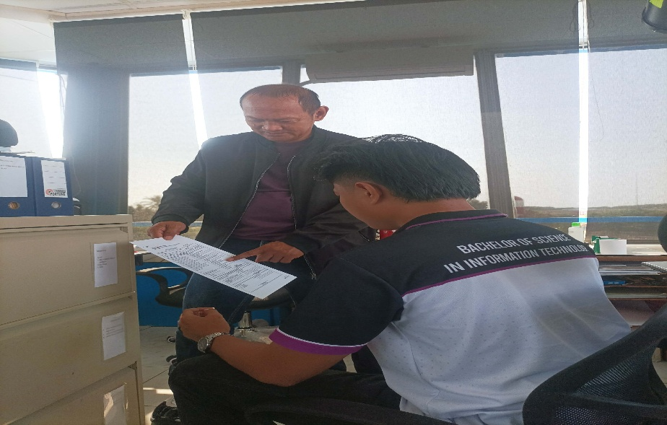
Orientation of UTC time and Hourly METAR/Weather updates from PAGASA

Jan 30, 2026 (Day 2) FRIDAY
In: 7:53 Am
Out: 5:14 Pm
8:00 am – 5:00 pm

Description:
- Participating in Airport Safety Awareness Program seminar
- Delivering documents from admin’s office to manager’s office to be signed by the Airport Manager II
- Preparing documents and to deliver at admin’s office

Type: Meeting and Activity
Hours: 8 hours

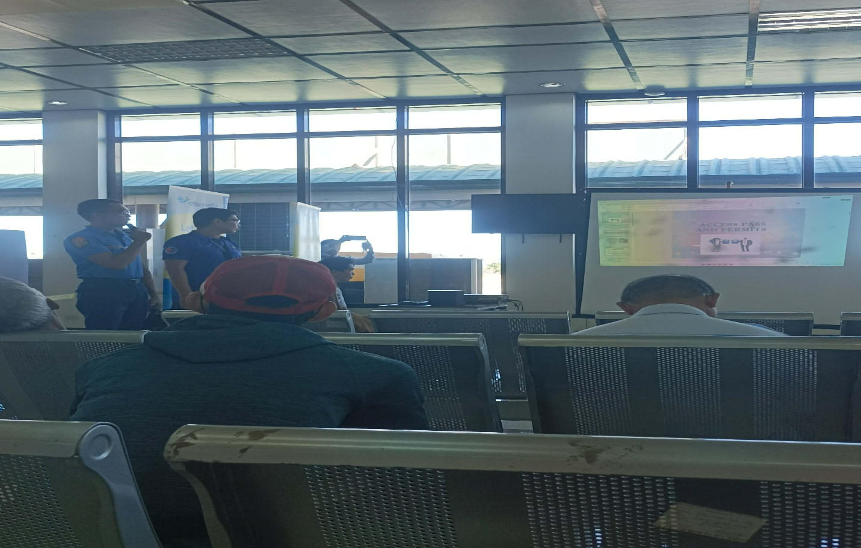
Airport Safety Awareness Program seminar
Feb 2, 2026 (Day 3) MONDAY
In: 7:56 Am
Out: 5:05 Pm

8:00 am – 5:00 pm

Description:
- Encoding Hourly METAR/Weather updates from PAGASA in Air Traffic Service (CADAS)
- Writing Hourly Weather Updates from PAGASA in Hourly METAR Form
- Delivering new documents to manager’s office from admin’s office
- Preparing Vouchers to be signed and deliver to Manager’s office.

Type: Activity
Hours: 8 hours

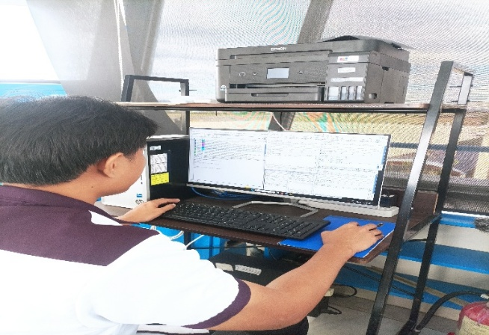
Encoding Hourly METAR/Weather updates from PAGASA in Air Traffic Service (CADAS)

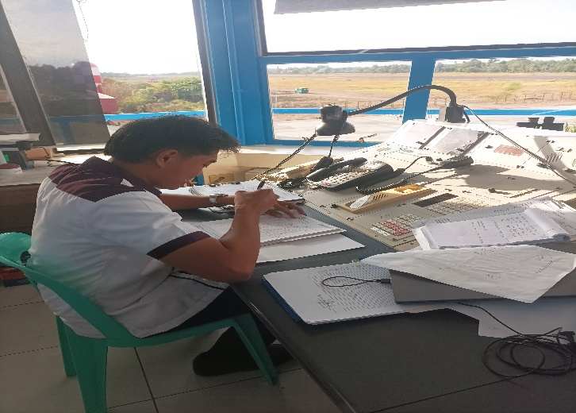
Writing Hourly Weather Updates from PAGASA in Hourly METAR Form
Feb 3, 2026 (Day 4) TUESDAY
In: 7:55 Am
Out: 5:05 Pm

8:00 am – 5:00 pm

Description:
- Encoding Hourly METAR/Weather updates from PAGASA in Air Traffic Service (CADAS)
- Writing Hourly Weather Updates from PAGASA in Hourly METAR Form
- Orientation of Enroute Chart.
- Filing printed Daily Time Records (DTR) and employee payslips in Admin’s Office

Type: Activity and Meeting
Hours: 8 hours
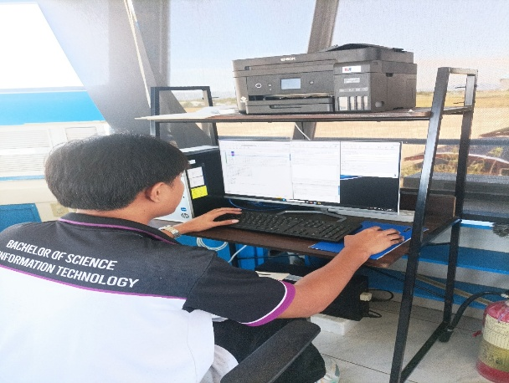

Encoding Hourly METAR/Weather updates from PAGASA in Air Traffic Service (CADAS)
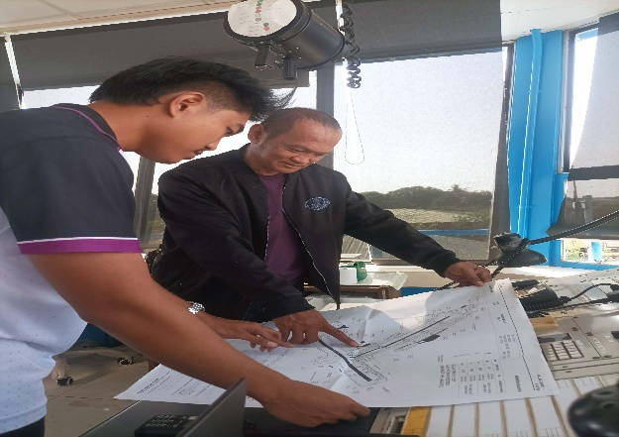
Orientation of Enroute Chart.

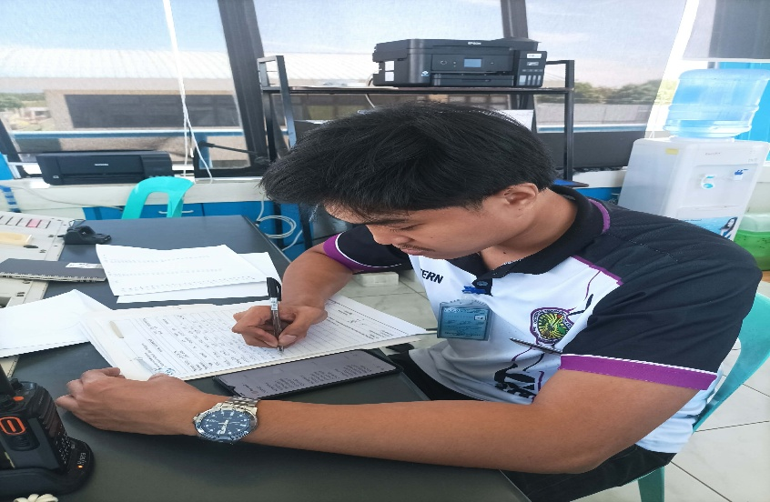
Writing Hourly Weather Updates from PAGASA in Hourly METAR Form
Feb 4, 2026 (Day 5) WEDNESDAY
In: 7:57am
Out: 5:03 pm

8:00 am – 5:00 pm

Description:
- Encoding Hourly METAR/Weather updates from PAGASA in Air Traffic Service (CADAS)
- Writing Hourly Weather Updates from PAGASA in Hourly METAR Form
- Preparing documents to be signed and deliver to Admin’s office.
- Sorting Statement of Salaries form in Admin’s Office.

Type: Activity
Hours: 8 hours

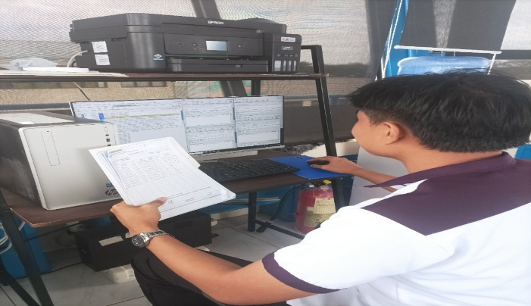
Encoding Hourly METAR/Weather updates from PAGASA in Air Traffic Service (CADAS)

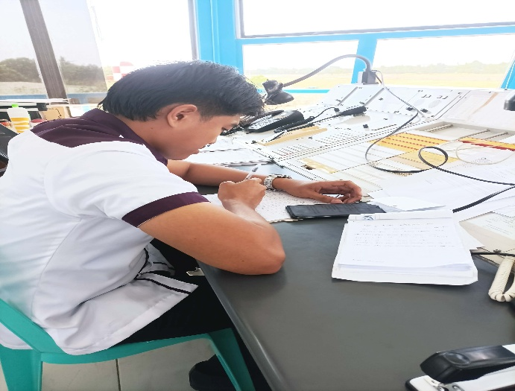
Writing Hourly Weather Updates from PAGASA in Hourly METAR Form
Feb 5, 2026 (Day 6) THURSDAY
In: 7:58 am
Out: 5:01 pm

8:00 am – 5:00 pm

Description:
- Encoding Hourly METAR/Weather updates from PAGASA in Air Traffic Service (CADAS)
- Writing Hourly Weather Updates from PAGASA in Hourly METAR Form
- Delivering documents to Fire office.

Type: Activity
Hours: 8 hours

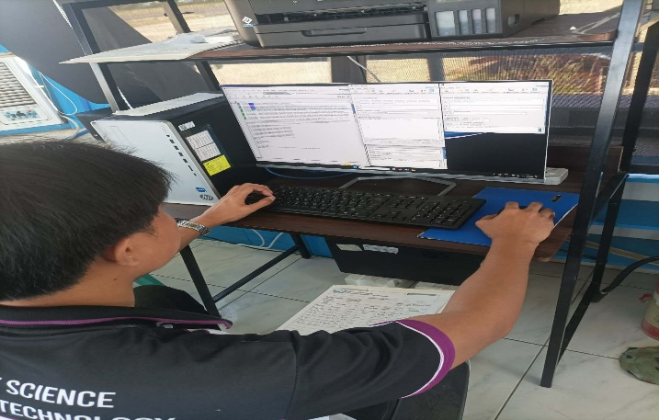
Encoding Hourly METAR/Weather updates from PAGASA in Air Traffic Service (CADAS)
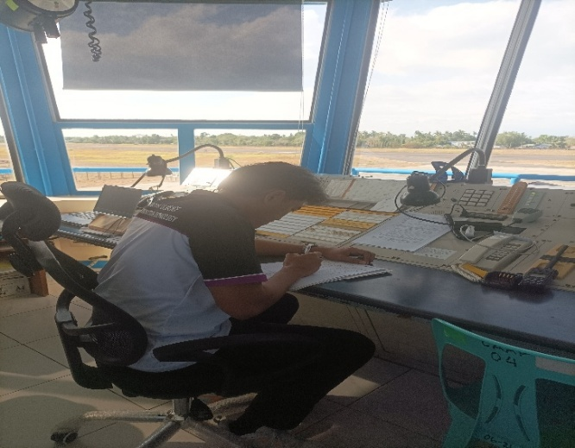
Writing Hourly Weather Updates from PAGASA in Hourly METAR Form
Feb 6, 2026 (Day 7) FRIDAY
In: 7:56 am
Out: 5:06 pm

8:00 am – 5:00 pm

Description:
- Encoding Hourly METAR/Weather updates from PAGASA in Air Traffic Service (CADAS)
- Writing Hourly Weather Updates from PAGASA in Hourly METAR Form
- Delivering unsigned documents from admin’s office to Maintenance
- Filing of receipts of purchased items in Admin’s Office

Type: Activity
Hours: 8 hours
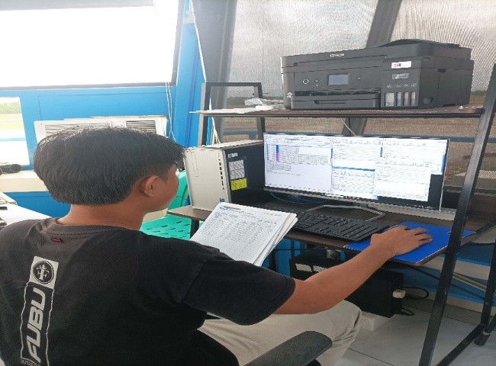
Encoding Hourly METAR/Weather updates from PAGASA in Air Traffic Service (CADAS)

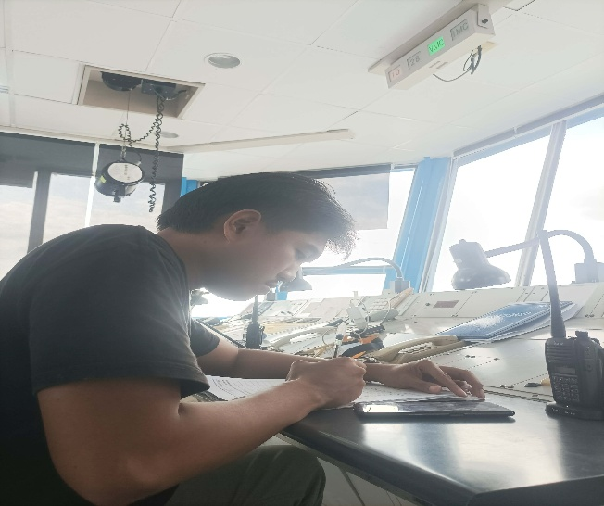
Writing Hourly Weather Updates from PAGASA in Hourly METAR Form
Feb 7, 2026 (Day 8) SATURDAY
In: 5:55 am
Out: 2:25 pm

6:00 am – 2:00 pm

Description:
- Encoding Hourly METAR/Weather updates from PAGASA in Air Traffic Service (CADAS)
- Writing Hourly Weather Updates from PAGASA in Hourly METAR Form

Type: Activity
Hours: 8 hours

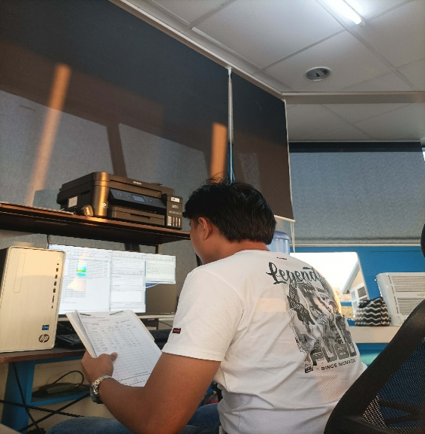
Encoding Hourly METAR/Weather updates from PAGASA in Air Traffic Service (CADAS)

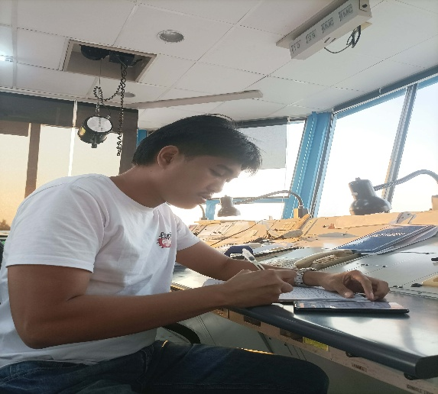
Writing Hourly Weather Updates from PAGASA in Hourly METAR Form
Feb 9, 2026 (Day 9) MONDAY
In: 5:56 am
Out: 2:20 pm

6:00 am – 2:00 pm

Description:
- Encoding Hourly METAR/Weather updates from PAGASA in Air Traffic Service (CADAS)
- Writing Hourly Weather Updates from PAGASA in Hourly METAR Form
- Encoding Aircraft Operations Data in Air Traffic Service (CADAS)
- Encoding Flight Plan in Air Traffic Service (CADAS)

Type: Activity
Hours: 8 hours
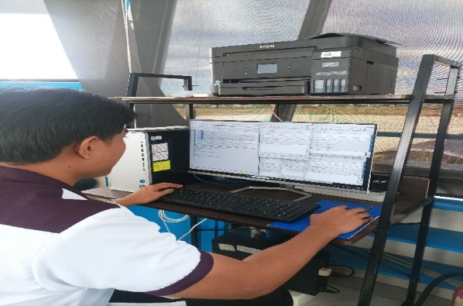
Encoding Hourly METAR/Weather updates from PAGASA, Aircraft Operations Data
and Flight Plan in Air Traffic Service (CADAS)

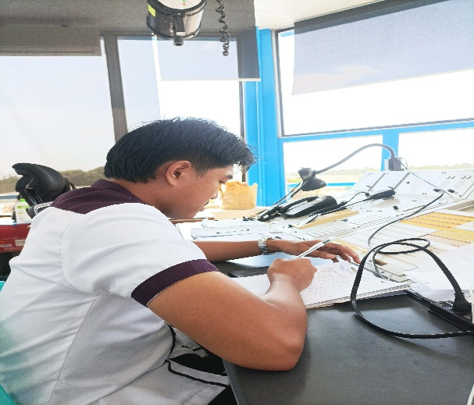
Writing Hourly Weather Updates from PAGASA in Hourly METAR Form

Feb 10, 2026 (Day 10) TUESDAY
In: 5:58 am
Out: 4:09 pm

6:00 am – 2:00 pm
OT:2hours
Description:
- Encoding Hourly METAR/Weather updates from PAGASA in Air Traffic Service (CADAS)
- Writing Hourly Weather Updates from PAGASA in Hourly METAR Form
- Encoding Aircraft Operations Data in Air Traffic Service (CADAS)
- Filing Documents in Management Office

Type: Activity
Hours: 10 hrs

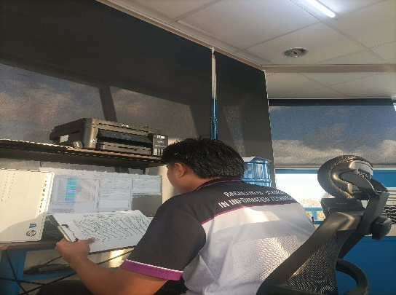
Encoding Hourly METAR/Weather updates from PAGASA and Aircraft Operations Data
in Air Traffic Service (CADAS)

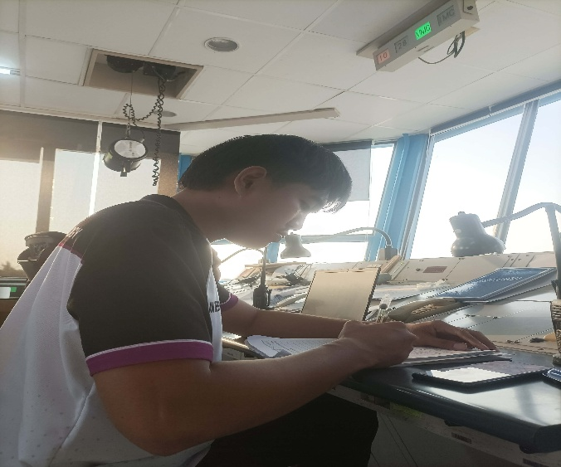
Writing Hourly Weather Updates from PAGASA in Hourly METAR Form
Feb 11, 2026 (Day 11) WEDNESDAY
In: 5:58 am
Out: 2:12 pm

6:00 am – 2:00 pm

Description:
- Encoding Hourly METAR/Weather updates from PAGASA in Air Traffic Service (CADAS)
- Writing Hourly Weather Updates from PAGASA in Hourly METAR Form
- Encoding Aircraft Operations Data in Air Traffic Service (CADAS)

Type: Activity
Hours: 8 hours
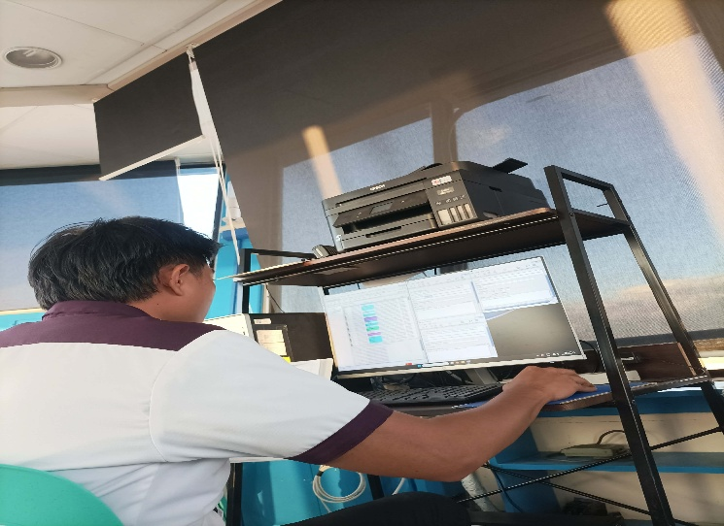
Encoding Hourly METAR/Weather updates from PAGASA and Aircraft Operations Data
in Air Traffic Service (CADAS)

Writing Hourly Weather Updates from PAGASA in Hourly METAR Form
Feb 12, 2026 (Day 12) THURSDAY
In: 5:59 am
Out: 5:02 pm

6:00 am – 2:00 pm

OT: 3 hours

Description:
- Encoding Hourly METAR/Weather updates from PAGASA in Air Traffic Service (CADAS)
- Writing Hourly Weather Updates from PAGASA in Hourly METAR Form
- Encoding Aircraft Operations Data in Air Traffic Service (CADAS)
- Filing Documents
- Delivering unsigned documents to Maintenance, Manager’s office and admin’s office signatories.

Type: Activity
Hours: 11:00 hrs
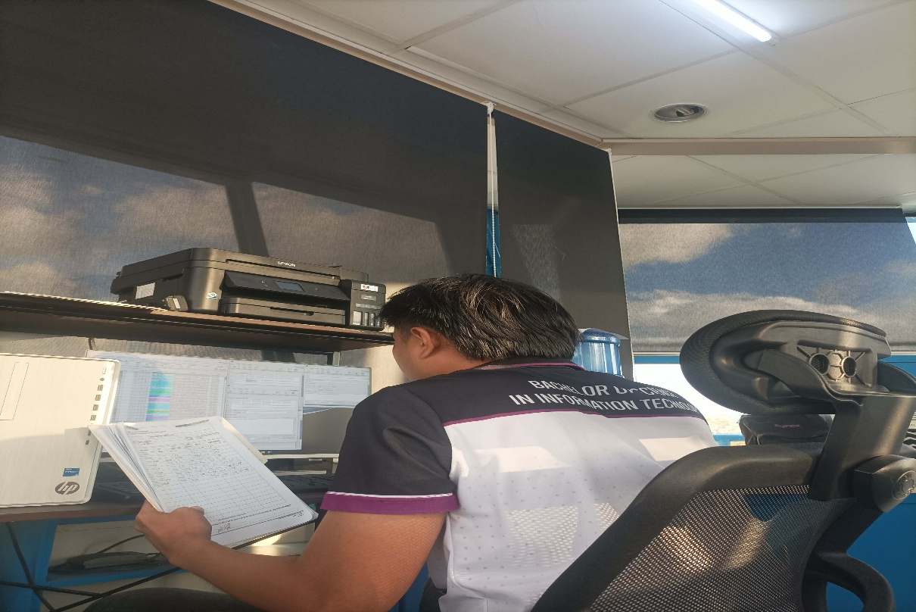
Encoding Hourly METAR/Weather updates from PAGASA and Aircraft Operations Data
in Air Traffic Service (CADAS)

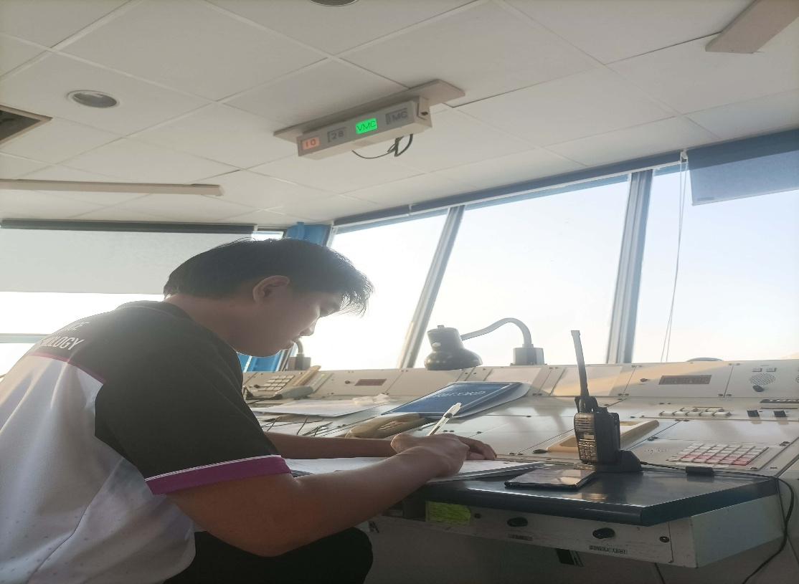

Writing Hourly Weather Updates from PAGASA in Hourly METAR Form

Feb 13, 2026 (Day 13) FRIDAY
In: 5:52 am
Out: 2:20 pm

6:00 am – 2:00 pm

Description:
- Encoding Hourly METAR/Weather updates from PAGASA in Air Traffic Service (CADAS)
- Writing Hourly Weather Updates from PAGASA in Hourly METAR Form
- Encoding Aircraft Operations Data in Air Traffic Service (CADAS)

Type: Activity
Hours: 8:00 hours
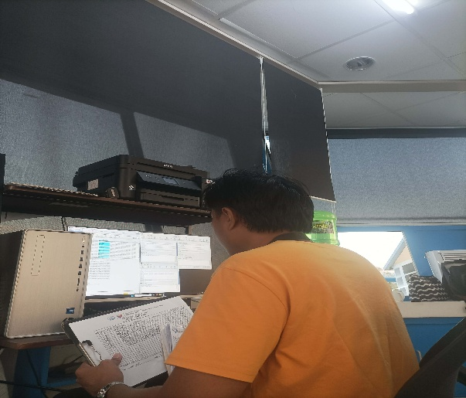
Encoding Hourly METAR/Weather updates from PAGASA and Aircraft Operations Data
in Air Traffic Service (CADAS)

Writing Hourly Weather Updates from PAGASA in Hourly METAR Form
Feb 16, 2026 (Day 14) MONDAY
In: 5:59 am
Out: 3:04 pm

6:00 am – 2:00 pm
OT: 1 hour
Description:
- Encoding Hourly METAR/Weather updates from PAGASA in Air Traffic Service (CADAS)
- Writing Hourly Weather Updates from PAGASA in Hourly METAR Form
- Encoding Aircraft Operations Data in Air Traffic Service (CADAS)
- Encoding Flight Plan in Air Traffic Service (CADAS)
- Filing of Flight plans and Runway Condition Assessment Worksheets in Air Traffic Service
Type: Activity
Hours: 9:00 hours
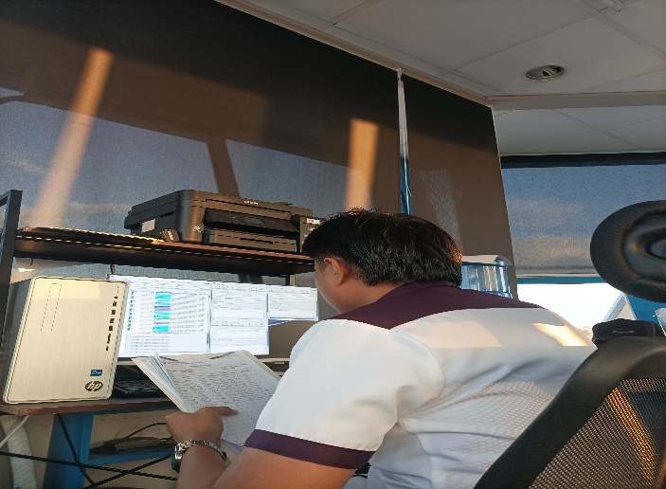
Encoding Hourly METAR/Weather updates from PAGASA, Aircraft Operations Data and Flight Plan
in Air Traffic Service (CADAS)
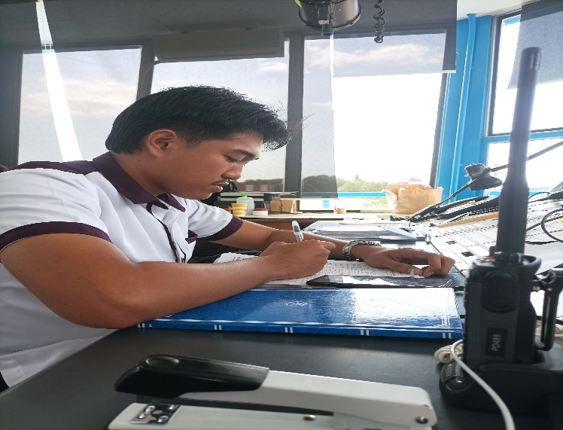
Writing Hourly Weather Updates from PAGASA in Hourly METAR Form
Feb 17, 2026 (Day 15) TUESDAY
In: 5:54 am
Out: 2:09 pm

6:00 am – 2:00 pm

Description:
- Encoding Hourly METAR/Weather updates from PAGASA in Air Traffic Service (CADAS)
- Writing Hourly Weather Updates from PAGASA in Hourly METAR Form
- Encoding Aircraft Operations Data in Air Traffic Service (CADAS)
- Encoding Arrival and Departure of Aircraft Landing and Takeoff at RPUH Air Traffic Service (CADAS)
- Filling of Runway Condition Assessment Worksheet in Air Traffic Service

Type: Activity
Hours: 8:00 hours
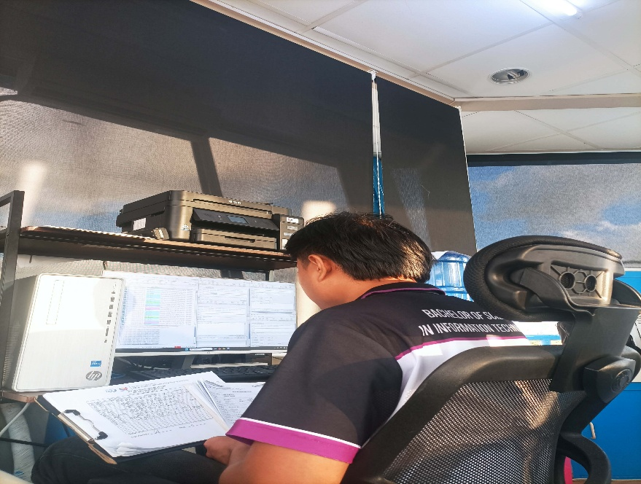
Encoding Hourly METAR/Weather updates from PAGASA, Aircraft Operations Data, Arrival and Departure of Aircraft Landing and Takeoff at RPUH Air Traffic Service (CADAS)


Writing Hourly Weather Updates from PAGASA in Hourly METAR Form

Feb 18, 2026 (Day 16) WEDNESDAY
In: 5:58 am
Out: 2:15 pm

6:00 am – 2:00 pm

Description:
- Encoding Hourly METAR/Weather updates from PAGASA in Air Traffic Service (CADAS)
- Writing Hourly Weather Updates from PAGASA in Hourly METAR Form
- Encoding Aircraft Operations Data in Air Traffic Service (CADAS)
- Filing of Flight plan in Air Traffic Service

Type: Activity
Hours: 8:00 hours

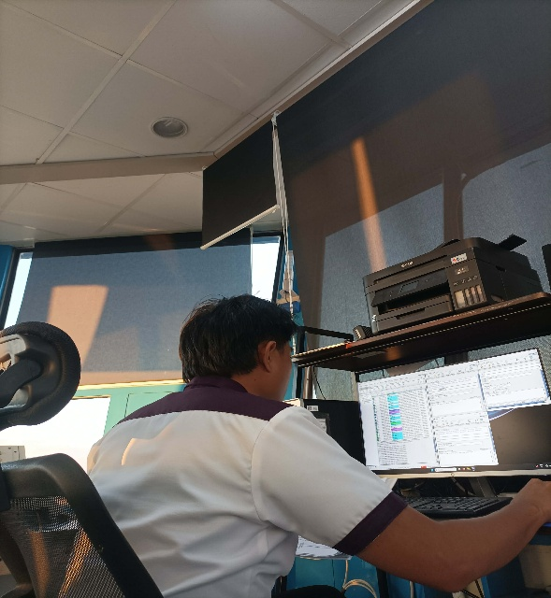
Encoding Hourly METAR/Weather updates from PAGASA and Aircraft Operations Data in Air Traffic Service (CADAS)

Writing Hourly Weather Updates from PAGASA in Hourly METAR Form
Feb 19, 2026 (Day 17) THURSDAY
In: 5:59 am
Out: 2:10 pm

6:00 am – 2:00 pm

Description:
- Encoding Hourly METAR/Weather updates from PAGASA in Air Traffic Service (CADAS)
- Writing Hourly Weather Updates from PAGASA in Hourly METAR Form
- Encoding Aircraft Operations Data in Air Traffic Service (CADAS)
- Filing of Flight plans and Runway Condition Assessment Worksheets in Air Traffic Service

Type: Activity
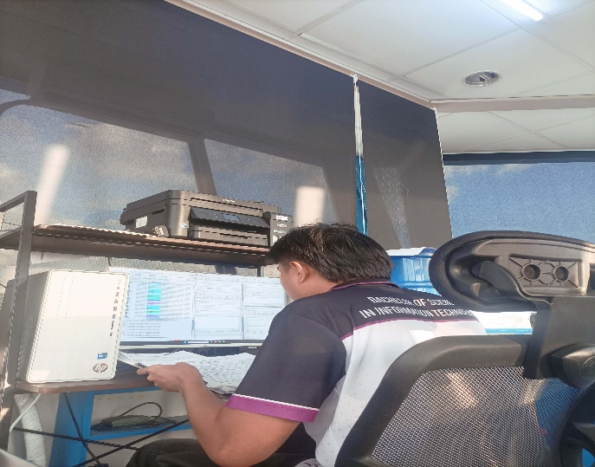
Hours: 8:00 hours
Encoding Hourly METAR/Weather updates from PAGASA and Aircraft Operations Data in Air Traffic Service (CADAS)
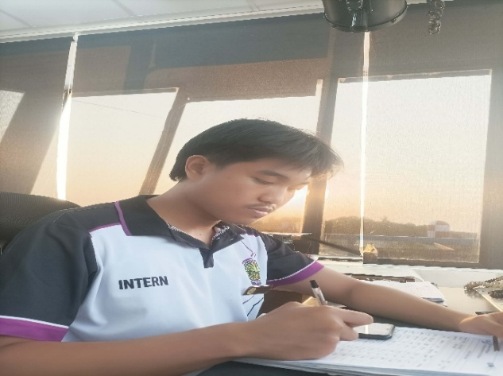
Writing Hourly Weather Updates from PAGASA in Hourly METAR Form
Feb 20, 2026 (Day 18) FRIDAY
In: 5:57 am
Out: 4:14 pm

6:00 am – 2:00 pm

OT: 2 hours

Description:
- Encoding Hourly METAR/Weather updates from PAGASA in Air Traffic Service (CADAS)
- Writing Hourly Weather Updates from PAGASA in Hourly METAR Form
- Encoding Aircraft Operations Data in Air Traffic Service (CADAS)
- Encoding Flight Plan in Air Traffic Service (CADAS)
- Encoding Arrival and Departure of Aircraft Landing and Takeoff at RPUH Air Traffic Service (CADAS)
- Editing RPUH Manual of Operations “Local Operating Procedures” in Air Traffic Service

Type: Activity
Hours: 10:00 hrs
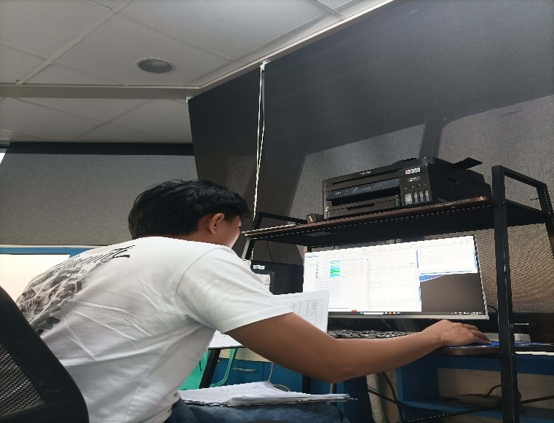
Encoding Hourly METAR/Weather updates from PAGASA, Aircraft Operations Data, Flight Plan, Arrival and Departure of Aircraft Landing and Takeoff at RPUH Air Traffic Service (CADAS)

Writing Hourly Weather Updates from PAGASA in Hourly METAR Form

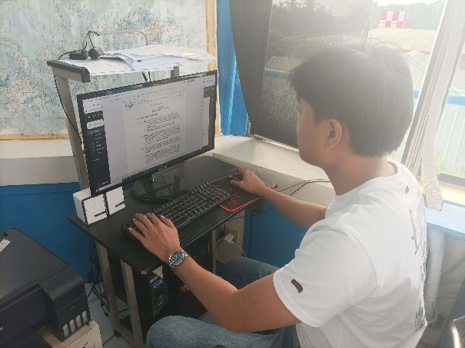
Editing RPUH Manual of Operations “Local Operating Procedures” in Air Traffic Service

Feb 23, 2026 (Day 19) MONDAY
In: 5:54 am
Out: 2:15 pm

6:00 am – 2:00 pm

Description:
- Encoding Hourly METAR/Weather updates from PAGASA in Air Traffic Service (CADAS)
- Writing Hourly Weather Updates from PAGASA in Hourly METAR Form
- Encoding Aircraft Operations Data in Air Traffic Service (CADAS)

Type: Activity
Hours: 8:00 hrs
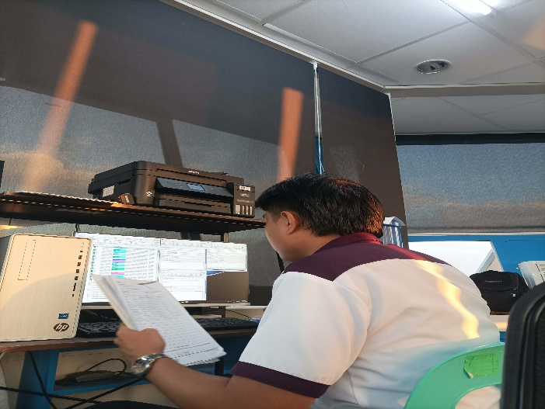
Encoding Hourly METAR/Weather updates from PAGASA and Aircraft Operations Data in Air Traffic Service (CADAS)
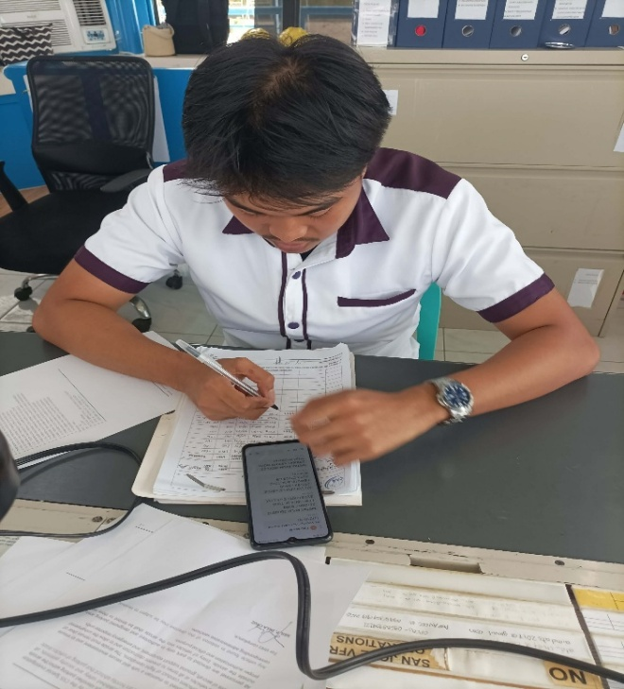
Writing Hourly Weather Updates from PAGASA in Hourly METAR Form
Feb 24, 2026 (Day 20) TUESDAY
In: 5:59 am
Out: 4:06 pm

6:00 am – 2:00 pm

OT: 2 hours

Description:
- Encoding Hourly METAR/Weather updates from PAGASA in Air Traffic Service (CADAS)
- Writing Hourly Weather Updates from PAGASA in Hourly METAR Form
- Encoding Aircraft Operations Data in Air Traffic Service (CADAS)
- Encoding Flight plan in Air Traffic Service (CADAS)
- Encoding Arrival and Departure of Aircraft Landing and Takeoff at RPUH Air Traffic Service (CADAS)

Type: Activity
Hours: 10:00 hrs
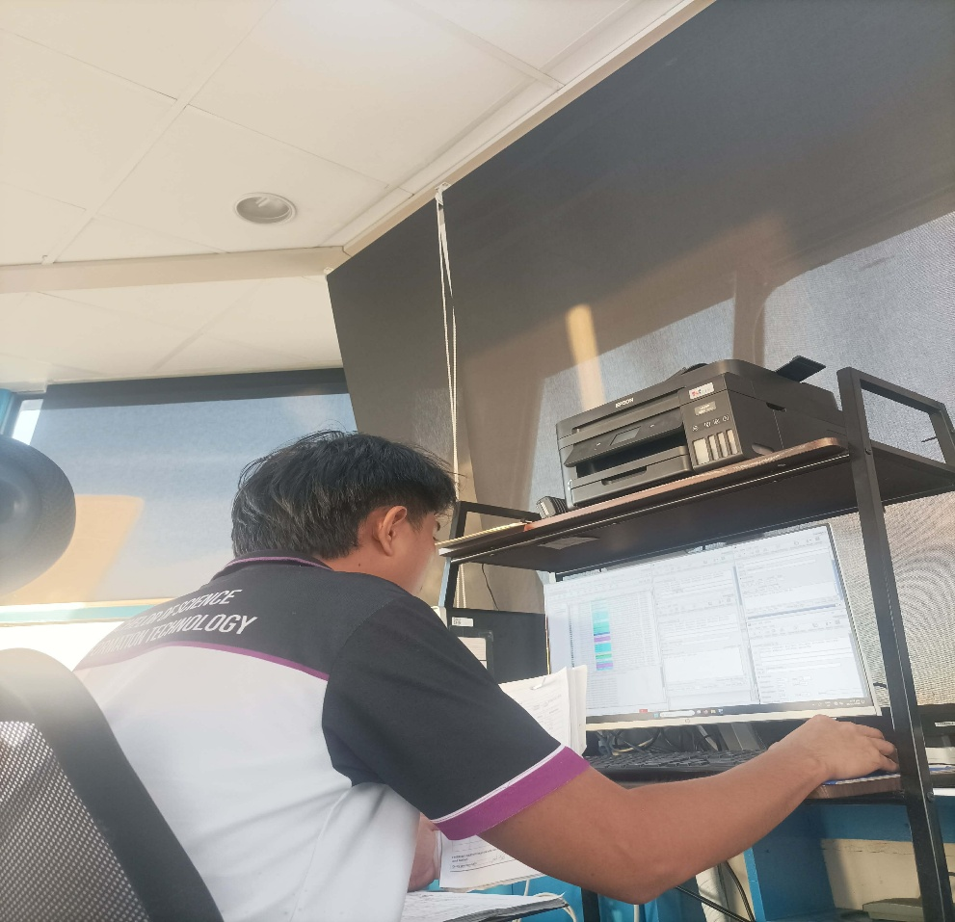
Encoding Hourly METAR/Weather updates from PAGASA, Aircraft Operations Data, Flight plan, Arrival and Departure of Aircraft Landing and Takeoff at RPUH Air Traffic Service (CADAS)
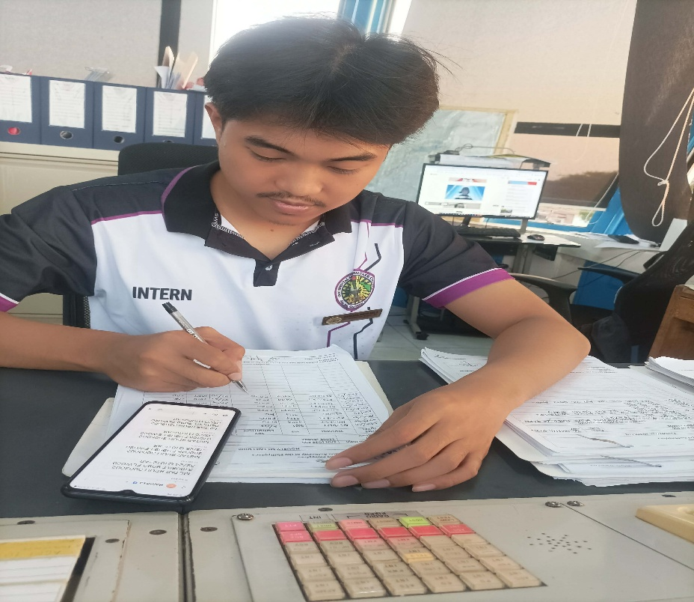
Writing Hourly Weather Updates from PAGASA in Hourly METAR Form

Feb 25, 2026 (Day 21) WEDNESDAY
In: 5:59 am
Out: 2:09 pm

6:00 am – 2:00 pm

Description:
- Encoding Hourly METAR/Weather updates from PAGASA in Air Traffic Service (CADAS)
- Writing Hourly Weather Updates from PAGASA in Hourly METAR Form
- Encoding Aircraft Operations Data in Air Traffic Service (CADAS)
- Encoding Flight Plan in Air Traffic Service (CADAS)
- Filing of Flight plans and Runway Condition Assessment Worksheets in Air Traffic Service

Type: Activity
Hours: 8:00 hrs
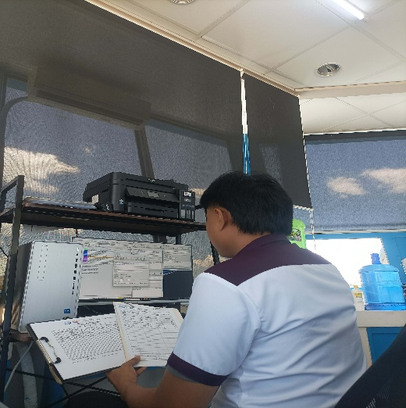
Encoding Hourly METAR/Weather updates from PAGASA, Aircraft Operations Data and Flight Plan in Air Traffic Service (CADAS)

Writing Hourly Weather Updates from PAGASA in Hourly METAR Form
Feb 26, 2026 (Day 22) THURSDAY
In: 6:00 am
Out: 2:07 pm

6:00 am – 2:00 pm

Description:
- Encoding Hourly METAR/Weather updates from PAGASA in Air Traffic Service (CADAS)
- Writing Hourly Weather Updates from PAGASA in Hourly METAR Form
- Encoding Aircraft Operations Data in Air Traffic Service (CADAS)

Type: Activity
Hours: 8:00 hrs
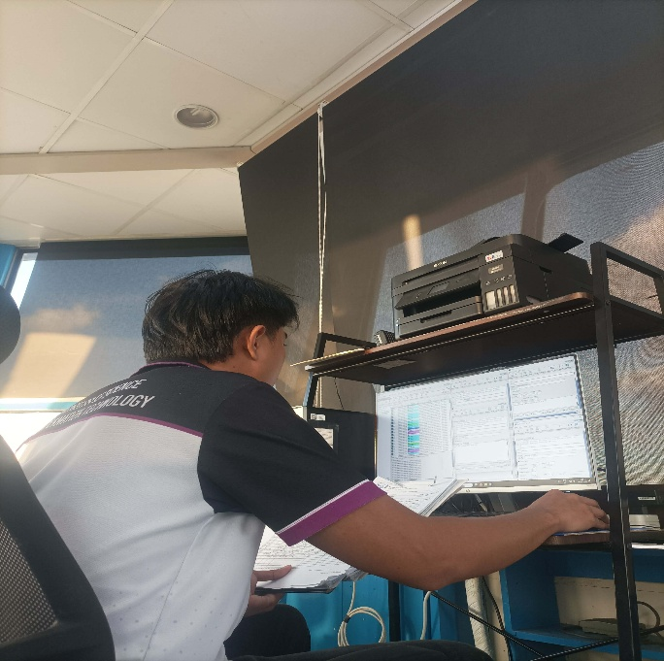
Encoding Hourly METAR/Weather updates from PAGASA and Aircraft Operations Data

Writing Weather Updates from PAGASA in Hourly METAR Form

Feb 27, 2026 (Day 23) FRIDAY
In: 5:59 am
Out: 2:55 pm

6:00 am – 2:00 pm

Description:
- Encoding Hourly METAR/Weather updates from PAGASA in Air Traffic Service (CADAS)
- Writing Hourly Weather Updates from PAGASA in Hourly METAR Form
- Encoding Aircraft Operations Data in Air Traffic Service (CADAS)
- Encoding Flight Plan in Air Traffic Service (CADAS)
- Filing of Quality Management System Regarding Facility Operations Documents in Air Traffic Service

Type: Activity
Hours: 8:00 hrs

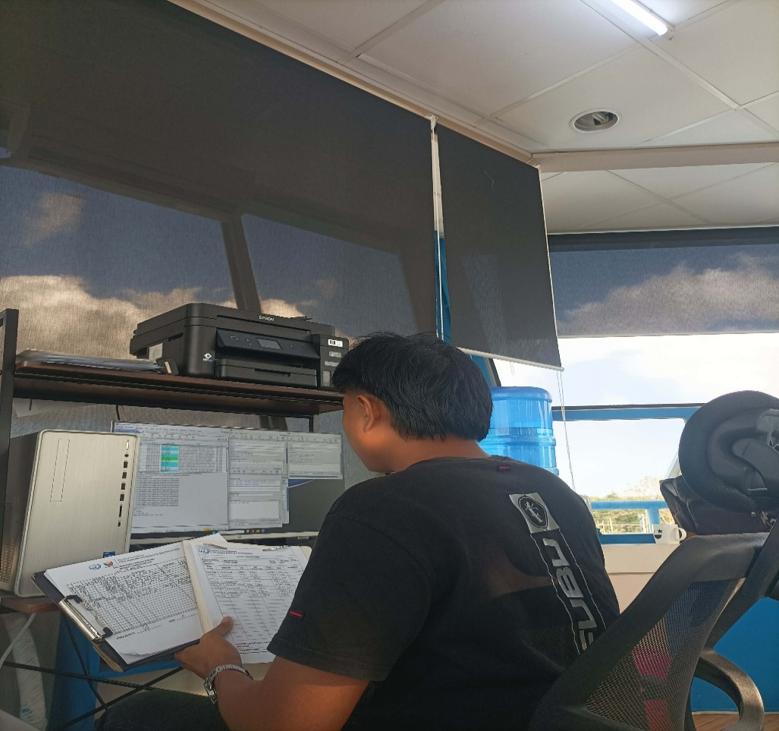
Encoding Hourly METAR/Weather updates from PAGASA, Aircraft Operations Data and Flight Plan in Air Traffic Service (CADAS)

Writing Weather Updates from PAGASA in Hourly METAR Form

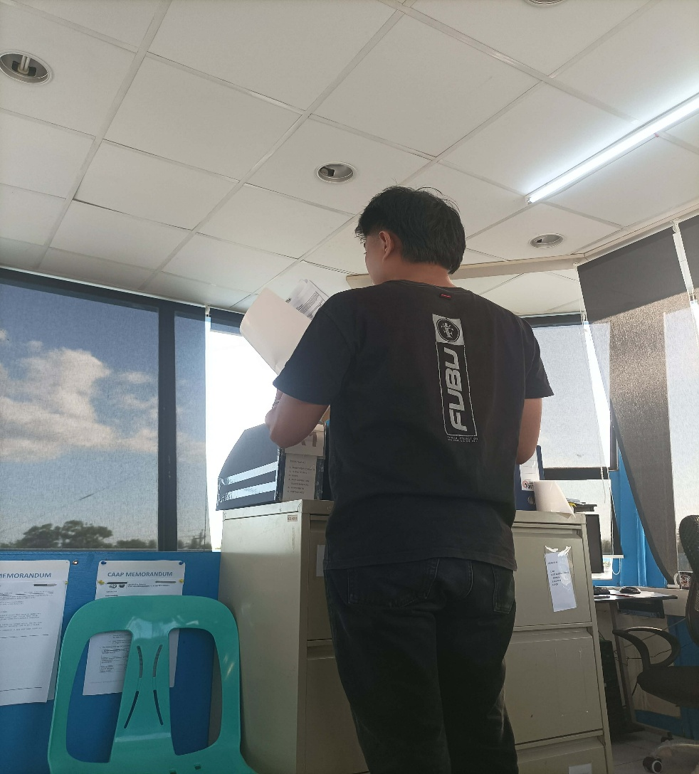
Filing of Quality Management System Regarding Facility Operations Documents in Air Traffic Service

Mar 2, 2026 (Day 24) MONDAY
In: 6:05 am
Out: 2:09 pm

6:00 am – 2:00 pm

Description:
- Encoding Hourly METAR/Weather updates from PAGASA in Air Traffic Service (CADAS)
- Writing Hourly Weather Updates from PAGASA in Hourly METAR Form
- Encoding Aircraft Operations Data in Air Traffic Service (CADAS)
- Encoding Flight Plan in Air Traffic Service (CADAS)
- Encoding Arrival and Departure of Aircraft Landing and Takeoff at RPUH Air Traffic Service (CADAS)
- Filling of Flight Plans and Runway Condition Assessment Worksheets in Air Traffic Service

Type: Activity
Hours: 8:00 hrs

Mar 3, 2026 (Day 25) TUESDAY
In: 5:58 am
Out: 2:19 pm

6:00 am – 2:00 pm

Description:
- Encoding Hourly METAR/Weather updates from PAGASA in Air Traffic Service (CADAS)
- Writing Hourly Weather Updates from PAGASA in Hourly METAR Form
- Encoding Aircraft Operations Data in Air Traffic Service (CADAS)

Type: Activity
Hours: 8:00 hrs

Mar 4, 2026 (Day-26) WEDNESDAY
In: 5:59 am
Out: 2:14 pm

6:00am - 2:00pm

Description:
- Encoding Hourly METAR/Weather updates from PAGASA in Air Traffic Service (CADAS)
- Writing Hourly Weather Updates from PAGASA in Hourly METAR Form
- Encoding Aircraft Operations Data in Air Traffic Service (CADAS)

Type: Activity

Hours: 8:00

Mar 5, 2026 (Day-27) THURSDAY
In: 6:01 am
Out: 2:19 pm

6:00am - 2:00pm

Description:

- Encoding Hourly METAR/Weather updates from PAGASA in Air Traffic Service (CADAS)
- Writing Hourly Weather Updates from PAGASA in Hourly METAR Form
- Encoding Aircraft Operations Data in Air Traffic Service (CADAS)

Type: Activity

Hours: 8:00

Mar 6, 2026 (Day-28) FRIDAY
In: 5:58 am
Out: 5:01 pm

6:00am - 2:00pm

OT: 3hrs

Description:

- Encoding Hourly METAR/Weather updates from PAGASA in Air Traffic Service (CADAS)
- Writing Hourly Weather Updates from PAGASA in Hourly METAR Form
- Encoding Aircraft Operations Data in Air Traffic Service (CADAS)
- Encoding Flight Plan in Air Traffic Service (CADAS)
- Encoding Arrival and Departure of Aircraft Landing and Takeoff at RPUH Air Traffic Service (CADAS)
- Filling of Flight Plans in Air Traffic Service
- Encoding Disbursements Data in Management Office

Type: Activity

Hours: 11:00

Mar 9, 2026 (Day-29) MONDAY
In: 5:57 am
Out: 2:14 pm

6:00am - 2:00pm

Description:

- Encoding Hourly METAR/Weather updates from PAGASA in Air Traffic Service (CADAS)
- Writing Hourly Weather Updates from PAGASA in Hourly METAR Form
- Encoding Aircraft Operations Data in Air Traffic Service (CADAS)

Type: Activity

Hours: 8:00

Mar 10, 2026 (Day-30) TUESDAY
In: 5:56 am
Out: 2:09 pm

6:00am - 2:00pm

Description:

- Encoding Hourly METAR/Weather updates from PAGASA in Air Traffic Service (CADAS)
- Writing Hourly Weather Updates from PAGASA in Hourly METAR Form
- Encoding Aircraft Operations Data in Air Traffic Service (CADAS)

Type: Activity

Hours: 8:00

Mar 11, 2026 (Day-31) WEDNESDAY
In: 5:58 am
Out: 2:11 pm

6:00am - 2:00pm

Description:

- Encoding Hourly METAR/Weather updates from PAGASA in Air Traffic Service (CADAS)
- Writing Hourly Weather Updates from PAGASA in Hourly METAR Form
- Encoding Aircraft Operations Data in Air Traffic Service (CADAS)
- Encoding Flight Plan in Air Traffic Service (CADAS)
- Encoding Arrival and Departure of Aircraft Landing and Takeoff at RPUH Air Traffic Service (CADAS)
- Filing of Flight plans in Air Traffic Service

Type: Activity

Hours: 8:00

Mar 12, 2026 (Day-32) THURSDAY
In: 5:57 am
Out: 2:28 pm

6:00am - 2:00pm

Description:

- Encoding Hourly METAR/Weather updates from PAGASA in Air Traffic Service (CADAS)
- Writing Hourly Weather Updates from PAGASA in Hourly METAR Form
- Encoding Aircraft Operations Data in Air Traffic Service (CADAS)
- Encoding Arrival and Departure of Aircraft Landing and Takeoff at RPUH Air Traffic Service (CADAS)

Type: Activity

Hours: 8:00

Mar 13, 2026 (Day-33) FRIDAY
In: 5:59 am
Out: 2:13 pm

6:00am - 2:00pm

Description:

- Encoding Hourly METAR/Weather updates from PAGASA in Air Traffic Service (CADAS)
- Writing Hourly Weather Updates from PAGASA in Hourly METAR Form
- Encoding Aircraft Operations Data in Air Traffic Service (CADAS)
- Filling of Runway Condition Assessment Worksheets in Air Traffic Service

Type: Activity

Hours: 8:00

Mar 16, 2026 (Day-34) MONDAY
In: 5:57 am
Out: 2:12 pm

6:00am - 2:00pm

Description:

- Encoding Hourly METAR/Weather updates from PAGASA in Air Traffic Service (CADAS)
- Writing Hourly Weather Updates from PAGASA in Hourly METAR Form
- Encoding Aircraft Operations Data in Air Traffic Service (CADAS)
- Filing of Flight plans in Air Traffic Service

Type: Activity

Hours: 8:00

Mar 17, 2026 (Day-35) TUESDAY
In: 5:54 am
Out: 2:10 pm

6:00am - 2:00pm

Description:

- Encoding Hourly METAR/Weather updates from PAGASA in Air Traffic Service (CADAS)
- Writing Hourly Weather Updates from PAGASA in Hourly METAR Form
- Encoding Aircraft Operations Data in Air Traffic Service (CADAS)
- Encoding Flight Plan in Air Traffic Service (CADAS)

Type: Activity

Hours: 8:00

Mar 18, 2026 (Day-36) WEDNESDAY
In: 5:54 am
Out: 2:12 pm

6:00am - 2:00pm

Description:

- Encoding Hourly METAR/Weather updates from PAGASA in Air Traffic Service (CADAS)
- Writing Hourly Weather Updates from PAGASA in Hourly METAR Form
- Encoding Aircraft Operations Data in Air Traffic Service (CADAS)
- Encoding Arrival and Departure of Aircraft Landing and Takeoff at RPUH Air Traffic Service (CADAS)

Type: Activity

Hours: 8:00

Mar 19, 2026 (Day-37) THURSDAY
In: 6:07am
Out: 2:21 pm

6:00am - 2:00pm

Description:

- Encoding Hourly METAR/Weather updates from PAGASA in Air Traffic Service (CADAS)
- Writing Hourly Weather Updates from PAGASA in Hourly METAR Form
- Encoding Aircraft Operations Data in Air Traffic Service (CADAS)
- Filing of Flight plans in Air Traffic Service

Type: Activity

Hours: 8:00

Mar 23, 2026 (Day-38) MONDAY
In: 5:56 am
Out: 2:08 pm

6:00am - 2:00pm

Description:

- Encoding Hourly METAR/Weather updates from PAGASA in Air Traffic Service (CADAS)
- Writing Hourly Weather Updates from PAGASA in Hourly METAR Form
- Encoding Aircraft Operations Data in Air Traffic Service (CADAS)
- Encoding Arrival and Departure of Aircraft Landing and Takeoff at RPUH Air Traffic Service (CADAS)

Type: Activity

Hours: 8:00

Mar 24, 2026 (Day-39) TUESDAY
In: 5:58 am
Out: 2:17 pm

6:00am - 2:00pm

Description:

- Encoding Hourly METAR/Weather updates from PAGASA in Air Traffic Service (CADAS)
- Writing Hourly Weather Updates from PAGASA in Hourly METAR Form
- Encoding Aircraft Operations Data in Air Traffic Service (CADAS)
- Encoding Flight Plan in Air Traffic Service (CADAS)
- Filing of Flight plans in Air Traffic Service

Type: Activity

Hours: 8:00

Mar 25, 2026 (Day-40) WEDNESDAY
In: 5:55 am
Out: 2:01 pm

6:00am - 2:00pm

Description:

- Encoding Hourly METAR/Weather updates from PAGASA in Air Traffic Service (CADAS)
- Writing Hourly Weather Updates from PAGASA in Hourly METAR Form
- Encoding Aircraft Operations Data in Air Traffic Service (CADAS)

Type: Activity

Hours: 8:00

Mar 26, 2026 (Day-41) THURSDAY
In: 5:58am
Out: 2:22 pm

6:00am - 2:00pm

Description:

- Encoding Hourly METAR/Weather updates from PAGASA in Air Traffic Service (CADAS)
- Writing Hourly Weather Updates from PAGASA in Hourly METAR Form
- Encoding Aircraft Operations Data in Air Traffic Service (CADAS)
- Encoding Flight Plan in Air Traffic Service (CADAS)
- Encoding Arrival and Departure of Aircraft Landing and Takeoff at RPUH Air Traffic Service (CADAS)
- Filing of Flight plans and Runway Condition Assessment Worksheets in Air Traffic Service

Type: Activity

Hours: 8:00

Mar 27, 2026 (Day-42) FRIDAY
In: 5:58 am
Out: 2:37 pm

6:00am - 2:00pm

Description:

- Encoding Hourly METAR/Weather updates from PAGASA in Air Traffic Service (CADAS)
- Writing Hourly Weather Updates from PAGASA in Hourly METAR Form
- Encoding Aircraft Operations Data in Air Traffic Service (CADAS)
- Communicating via Ground to Air Frequency 118.3 MHz in Air Traffic Service

Type: Activity

Hours: 8:00

Mar 28, 2026 (Day-43) SATURDAY
In: 6:00 am
Out: 2:17 pm

6:00am - 2:00pm

Description:

- Encoding Hourly METAR/Weather updates from PAGASA in Air Traffic Service (CADAS)
- Writing Hourly Weather Updates from PAGASA in Hourly METAR Form
- Encoding Aircraft Operations Data in Air Traffic Service (CADAS)

Type: Activity

Hours: 8:00

Mar 30, 2026 (Day-44) MONDAY
In: 6:00 am
Out: 2:27 pm

6:00am - 2:00pm

Description:

- Encoding Hourly METAR/Weather updates from PAGASA in Air Traffic Service (CADAS)
- Writing Hourly Weather Updates from PAGASA in Hourly METAR Form
- Encoding Aircraft Operations Data in Air Traffic Service (CADAS)
- Encoding Flight plan in Air Traffic Service (CADAS)
- Encoding Arrival and Departure of Aircraft Landing and Takeoff at RPUH Air Traffic Service (CADAS)
- Filing of Flight plans in Air Traffic Service

Type: Activity

Hours: 8:00

Mar 31, 2026 (Day-45) TUESDAY
In: 5:55 am
Out: 2:26 pm

6:00am - 2:00pm

Description:

- Encoding Hourly METAR/Weather updates from PAGASA in Air Traffic Service (CADAS)
- Writing Hourly Weather Updates from PAGASA in Hourly METAR Form
- Encoding Aircraft Operations Data in Air Traffic Service (CADAS)
- Filing of Quality Management System Regarding Facility Operations Documents in Air Traffic Service

Type: Activity

Hours: 8:00

Apr 1, 2026 (Day-46) WEDNESDAY
In: 6:01 am
Out: 2:07 pm

6:00am - 2:00pm

Description:

- Encoding Hourly METAR/Weather updates from PAGASA in Air Traffic Service (CADAS)
- Writing Hourly Weather Updates from PAGASA in Hourly METAR Form
- Encoding Aircraft Operations Data in Air Traffic Service (CADAS)

Type: Activity

Hours: 8:00

Apr 6, 2026 (Day-47) MONDAY
In: 5:59 am
Out: 2:19 pm

6:00am - 2:00pm

Description:

- Encoding Hourly METAR/Weather updates from PAGASA in Air Traffic Service (CADAS)
- Writing Hourly Weather Updates from PAGASA in Hourly METAR Form
- Encoding Aircraft Operations Data in Air Traffic Service (CADAS)
- Encoding Flight Plan in Air Traffic Service (CADAS)
- Encoding Arrival and Departure of Aircraft Landing and Takeoff at RPUH Air Traffic Service (CADAS)

Type: Activity

Hours: 8:00

Apr 8, 2026 (Day-48) WEDNESDAY
In: 5:52 am
Out: 2:13 pm

6:00am - 2:00pm

Description:

- Encoding Hourly METAR/Weather updates from PAGASA in Air Traffic Service (CADAS)
- Writing Hourly Weather Updates from PAGASA in Hourly METAR Form
- Encoding Aircraft Operations Data in Air Traffic Service (CADAS)

Type: Activity

Hours: 8:00

Apr 9, 2026 (Day-49) THURSDAY
In: 5:59 am
Out: 5:18 pm

6:00am - 2:00pm

OT: 3hrs

Description:

- Encoding Hourly METAR/Weather updates from PAGASA in Air Traffic Service (CADAS)
- Writing Hourly Weather Updates from PAGASA in Hourly METAR Form
- Encoding Aircraft Operations Data in Air Traffic Service (CADAS)
- Encoding Flight Plan in Air Traffic Service (CADAS)
- Filing of Flight plans and Runway Condition Assessment Worksheets in Air Traffic Service
- Filing of Disbursement Vouchers in Management Office

Type: Activity

Hours: 11:00

Apr 10, 2026 (Day-50) FRIDAY
In: 5:57 am
Out: 2:17 pm

6:00am - 2:00pm

Description:

- Encoding Hourly METAR/Weather updates from PAGASA in Air Traffic Service (CADAS)
- Writing Hourly Weather Updates from PAGASA in Hourly METAR Form
- Encoding Aircraft Operations Data in Air Traffic Service (CADAS)

Type: Activity

Hours: 8:00

Apr 13, 2026 (Day-51) MONDAY
In: 5:57 am
Out: 5:07 pm

6:00am - 2:00pm

OT:3hours

Description:

- Encoding Hourly METAR/Weather updates from PAGASA in Air Traffic Service (CADAS)
- Writing Hourly Weather Updates from PAGASA in Hourly METAR Form
- Encoding Aircraft Operations Data in Air Traffic Service (CADAS)
- Encoding Arrival and Departure of Aircraft Landing and Takeoff at RPUH Air Traffic Service (CADAS)
- Filing of Routing Action slip and Salaries Form in Management Office

Type: Activity

Hours: 11:00

Apr 14, 2026 (Day-52) TUESDAY
In: 5:58 am
Out: 6:00 pm

6:00am - 2:00pm

OT:4hours

Description:

- Encoding Hourly METAR/Weather updates from PAGASA in Air Traffic Service (CADAS)
- Writing Hourly Weather Updates from PAGASA in Hourly METAR Form
- Encoding Aircraft Operations Data in Air Traffic Service (CADAS)
- Encoding Flight Plan in Air Traffic Service (CADAS)
- Encoding Arrival and Departure of Aircraft Landing and Takeoff at RPUH Air Traffic Service (CADAS)
- Filing of Flight plans and Runway Condition Assessment Worksheets in Air Traffic Service
- Filing of Sworn Statement of Assets, Liabilities and Net Worth in Management Office

Type: Activity

Hours: 12:00

Apr 15, 2026 (Day-53) WEDNESDAY
In: 5:58 am
Out: 2:19 pm

6:00am - 2:00pm

Description:

- Encoding Hourly METAR/Weather updates from PAGASA in Air Traffic Service (CADAS)
- Writing Hourly Weather Updates from PAGASA in Hourly METAR Form
- Encoding Aircraft Operations Data in Air Traffic Service (CADAS)

Type: Activity

Hours: 8:00

Apr 16, 2026 (Day-54) THURSDAY
In: 5:59 am
Out: 5:17 pm

6:00am - 2:00pm
OT: 3hours

Description:

- Encoding Hourly METAR/Weather updates from PAGASA in Air Traffic Service (CADAS)
- Writing Hourly Weather Updates from PAGASA in Hourly METAR Form
- Encoding Aircraft Operations Data in Air Traffic Service (CADAS)
- Filing Manual Transactions and Protocols in Management Office

Type: Activity

Hours: 11:00

Apr 17, 2026 (Day-55) FRIDAY
In: 6:13 am
Out: 2:34 pm

6:00am - 2:00pm

Description:

- Encoding Hourly METAR/Weather updates from PAGASA in Air Traffic Service (CADAS)
- Writing Hourly Weather Updates from PAGASA in Hourly METAR Form
- Encoding Aircraft Operations Data in Air Traffic Service (CADAS)

Type: Activity

Hours: 8:00

Apr 20, 2026 (Day-56) MONDAY
In: 5:59 am
Out: 5:17 pm

6:00am - 2:00pm

OT: 3hours

Description:

- Encoding Hourly METAR/Weather updates from PAGASA in Air Traffic Service (CADAS)
- Writing Hourly Weather Updates from PAGASA in Hourly METAR Form
- Encoding Aircraft Operations Data in Air Traffic Service (CADAS)
- Filing Budget Utilization Request and Status in Management Office

Type: Activity

Hours: 11:00

Apr 21, 2026 (Day-57) TUESDAY
In 6:34 am
Out: 5:12 pm

6:00am - 2:00pm

OT: 3hours

Description:

- Encoding Hourly METAR/Weather updates from PAGASA in Air Traffic Service (CADAS)
- Writing Hourly Weather Updates from PAGASA in Hourly METAR Form
- Encoding Aircraft Operations Data in Air Traffic Service (CADAS)
- Filing Requisition and Issue Slip in Management Office

Type: Activity

Hours: 11:00

Internship Time Summary

Total hours: 486
Working Days: 57
Avg. Hours/day: 8.47

Hours by Activity Type

Activities: 94.74%
Meetings: 5.26%

C. Internship Progress Report

Internship Overview
Complete record of internship details, objectives and accomplishments.

Name: Micah Mel Madriaga
Course: Bachelor of Science in Information Technology
Agency: Civil Aviation Authority of the Philippines
Period Covered: Jan 29, 2026 – April 21, 2026
Total hours: 486
OJT Training: Face to face

Internship Objectives & Status

Objectives | Work Status | Problems
Encoding Hourly METAR/Weather Updates from PAGASA in Air Traffic Service (CADAS) | Accomplished | None
Writing Weather Updates from PAGASA in Hourly METAR Forms | Accomplished | None
Encoding Aircraft Operations Data in Air Traffic Service (CADAS) | Accomplished | None
Encoding Flight Plans in Air Traffic Service (CADAS) | Accomplished | None
Encoding Arrival and Departure of Aircraft (Landing and Takeoff) in Air Traffic Service (CADAS) | Accomplished | None
Assisting in general administrative and operational tasks | Accomplished | None
Organizing and filing administrative documents (DTR, payslips, receipts, salary forms) | Accomplished | None
Communicating via Ground-to-Air Frequency (118.3 MHz) in Air Traffic Service | Accomplished | None
Filing of Quality Management System Documents for Facility Operations in Air Traffic Service | Accomplished | None

D. Internship Analysis Report

Setting

The setting was good because it provided a real and professional aviation environment where I was able to perform actual tasks in Air Traffic Service such as encoding METAR/weather updates, Flight plans, Aircraft Operations Data, and Arrival and Departure data using CADAS.

The setting was limited by restricted access, as interns were not allowed directly to handle live communication with pilots and also were not allowed to operate control systems because air traffic operations are safety-critical and can only be handled by trained and licensed personnel to prevent errors and ensure the safety of aircraft and passengers.

My initial analysis of the agency or organization was the CAAP Air Traffic Service is a highly disciplined organization that prioritizes accuracy, safety, and compliance in aviation operations.

Supervisor

The greatest contribution made by the site supervisor was providing a clear guidance, proper instructions, and continuous support in performing assigned tasks, especially in data encoding, filing, and operational procedures.

The general level of supervision was appropriate and professional.

I needed more from the supervisor in the way of more detailed explanations and demonstrations of advanced Air traffic operations.

Environmental Conditions or events

The one event/characteristic that really influenced my internship was working with real-time aviation data that requires accuracy and timely action in daily operations.

A trend/issue which really impacted this organization was the constant requirement for precise and error-free data encoding, as even minor mistakes can affect flight operations and safety.

Diversity of co-workers or target audiences provided an opportunity to improve my communication skills, teamwork, and coordination with different offices such as Admin, Maintenance, and Management.

Self-assessment

The most important thing I learned is how to handle responsibilities to perform assigned tasks in Air Traffic Service.

I contributed to the organization by accurately encoding Weather Updates from PAGASA, Flight Plans, and Aircraft Operations Data as well as assisting in filing and administrative tasks.

I still need more experience in the area of Air Traffic Service to communicate with pilots using equipment such as radio frequencies.

If I were to repeat this experience I would be more proactive in asking questions about what I need to know and I will maximize every opportunity to learn, hoping that one day I will become a full-fledged Air Traffic Controller. If I achieve that goal, I believe it is meant to be my destiny.

General

The internship experience can be strengthened by providing more structured training, such as demonstrations or simulations of actual air traffic operations.

Future interns should be responsible, observant, and willing to learn. They should take initiative, ask questions, and always pay attention to details.
Chapter IV

Assessment of the Practicum Program
Evaluation and Performance Review

A. Student Internship Evaluation Form

STUDENT INTERNSHIP PERFORMANCE EVALUATION

Student Name: Micah Mel R. Madriaga
Student ID: MA22-IT-06293
Program/Course: BS Information Technology
Academic Year: 2025-2026
Internship Start Date: January 29, 2026
Internship End Date: April 21, 2026
Company: Civil Aviation Authority of the Philippines
Department: Air Traffic Service
Supervisor: Delmer M. Palara
Position: Intern

Performance Evaluation

Official evaluation documentation from CAAP Air Traffic Service and Occidental Mindoro State College.

Performance Evaluation Summary

Ratings Overview

SR — Student Self-Rating: 285
PR — Peer Rating: 285
SICR — Student Internship Coordinator Rating:
ASR — Agency Supervisor Rating: 285

General Comments on Student's Overall Performance

“Highly Knowledgeable in Assigned Tasks and always willing to learn new things.”

Overall Rating

Rated by:

Student Intern:
Micah Mel R. Madriaga
April 22, 2026

Peer:
Aylene Z. Villanueva
April 22, 2026

Student Internship Coordinator:
Marites D. Escultor, MSIT

Agency Supervisor:
Delmer M. Palara
April 22, 2026

Appendices

APPENDICES
Supporting Documents and References

Supporting Documentation

This page contains all supporting documents relevant to the On-the-Job Training experience, including official forms, certifications, and visual documentation of the internship.

Official Documents

Appendix A (Evaluation Form)

Appendix B (Photocopy Registration Form)

Appendix C (Photocopy Validated ID)

Appendix D (Parent's Consent)

Appendix E (Medical Certificate)

Appendix F (Certificate of Good Moral Character)

Appendix G (Application Letter)

Appendix H (Endorsement Letter)

Appendix I (Memorandum of Agreement)
Appendix J (Daily Time Record (Time Card)

Appendix K (Certificate of Completion)

Appendix L (Certificate of Clearance)

Visual Documentation

Appendix N

Pictures during Pre-service Seminar
Photo documentation of participation in the pre-service seminar

Appendix O

Pictures during Office Works
Photo documentation of various activities and tasks performed during the internship at CAAP Air Traffic Service

Code of Ethics

Appendix P

Code of Ethics for CAST Student Internship
Official code of ethics that governed student conduct during the internship.

Appendix Q (Curriculum Vitae)

Portfolio Evaluation

Appendix R

On-the-Job Training Portfolio Evaluation Form
Official form used to evaluate this OJT portfolio submission

